Here is an example:

**Twitter Clone Assignment** 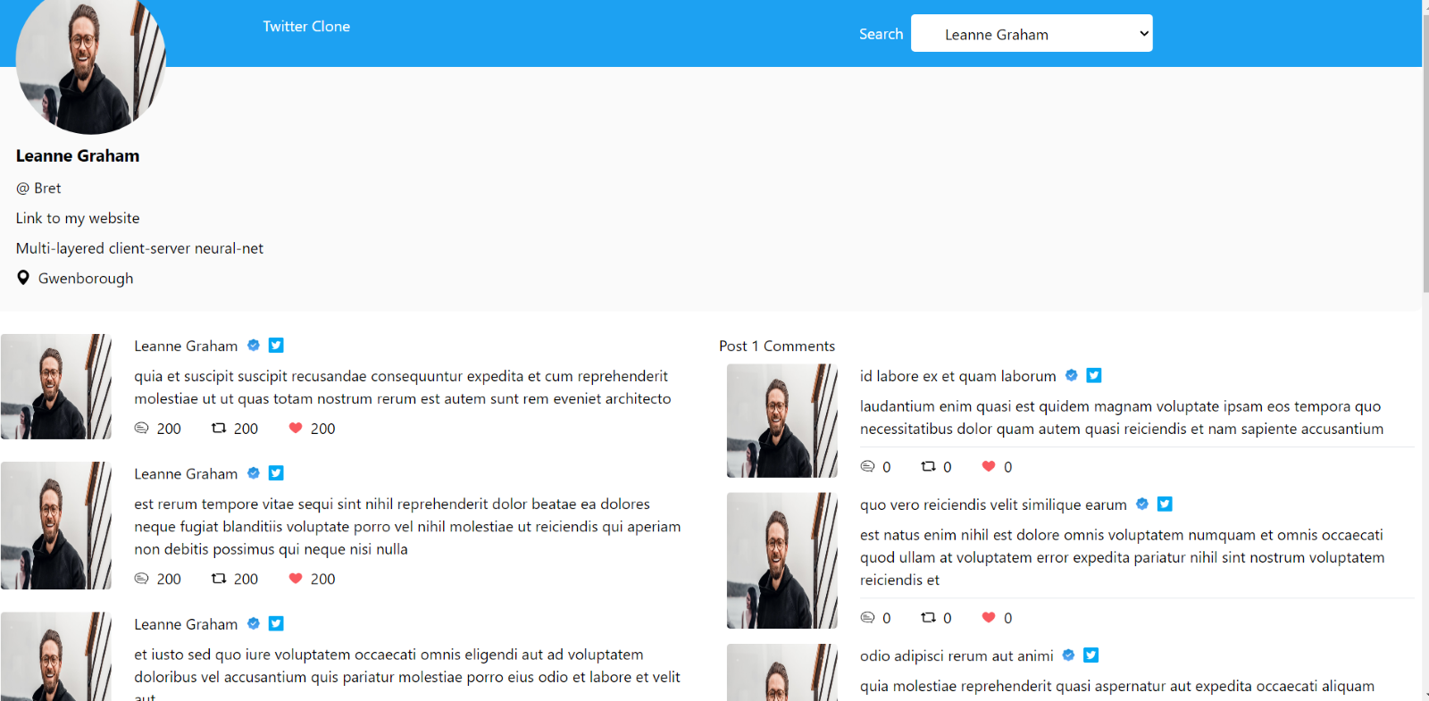

**Part 1**

For the user details and information select one user from this API: <https://jsonplaceholder.typicode.com/users>

E.g., you can select user 1: <https://jsonplaceholder.typicode.com/users/1>

Use the information of the user to build the profile page (some data might be missing- hard code or ignore but use your own images)

**Part 2 the posts/tweets**

Depending on the selected user

Get his/her posts from this API: <https://jsonplaceholder.typicode.com/posts> (filter by your selected userId)

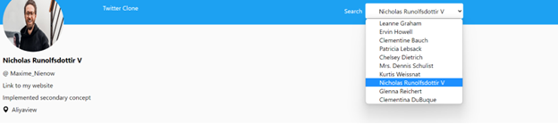

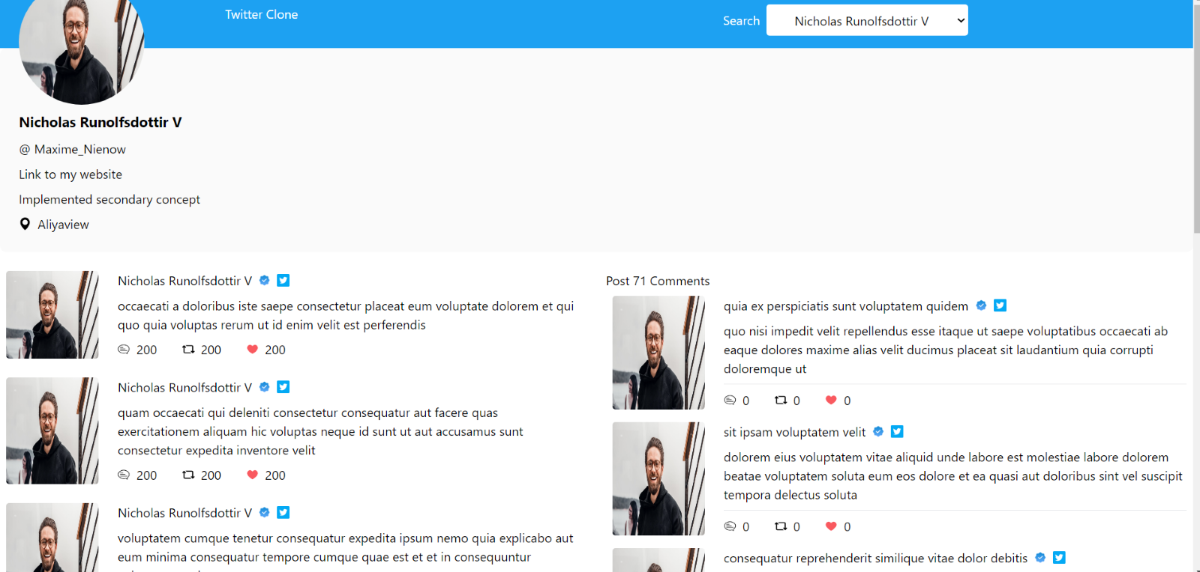

**Part 3**

Add a show comment to every post and on-click show the comment for the post

Get the comments from <https://jsonplaceholder.typicode.com/comments> ( filter by postID)

By default show the comments of the first post of the user E.g. for user 1 show the comments of the first post.